**Severe biological effects due to current ocean acidification conditions in the highly variable fjord-like estuarine regimes of the Salish Sea**

**Authors and Institutions- TBD**

**Abstract- later**

**Introduction**

The comprehensive understanding of oceanographic processes controlling spatial and temporal variations in ocean acidification (OA) conditions in the open ocean and nearshore regions has improved our capability to identify the drivers, distinguish between natural and anthropogenic signals, and predict future scenarios and trends under climate change scenarios. Especially in the coastal region of the California Current System (CCS), OA conditions have started to increase in the magnitude, duration and frequency (Gruber et al., 2012; Turi et., 2016; Hauri et al., 2015; Chan et al., 2016; Chavez et al., 2017; Sutton et al., 2019), with detrimental impacts on the most vulnerable marine communities, such as ecologically and economically important pelagic and benthic calcifiers (Bednaršek et al., 2014; 2016; Bednaršek et al., in revisions; Kapsenberg et al., 2018).

Compared to the coastal systems, estuaries reflect the processes on a regional and local level, characterized by natural fluctuations that vary cross different time and spatial scales. Complex interaction of processes, such as intense respiration, freshwater (riverine) inputs, and other redox reactions, result in seasonally prolonged low pH and aragonite saturation state (Ωar). Furthermore, anthropogenic input as river run-off, wastewater and local CO2 atmospheric depositions, can further intensity the exposure, lowering acid buffering capacity of the estuaries (Cai et al., 2017) which results in rapid shift of the baseline biological thresholds across the species and estuarine communities (Shaw et al., 2013). Despite high baseline OA vulnerability, current understanding of the biological impact caused by estuarine acidification is still scares, especially the effects of prolonged seasonal exposure and long-term decreases in Ωar typical for the estuarine systems. Contrary to the open ocean observations, where the gradual underlining trends allow making biological inferences based on less frequent observations, highly variable estuarine regimes rely on frequently sampled time series to monitor how the extreme events, variability and its prolonged exposure, dictate biological responses.

The Salish Sea is a complex fjord-like estuarine system in the Pacific Northwest that includes variety of smaller embayments with secondary estuaries, deltas, rocky shores and beaches. It supports abundant biological, recreational, cultural and economic resources (Ref.). With respect to OA exposure, the system has one of the strongest temporally and spatially variable OA patterns, varying from daily, seasonal and inter-annual scales across a variety of different spatial habitats. In the late spring and summer, coastal upwelling makes an important contribution to the delivery of cold, CO2-enriched, oxygen-depleted water into the Salish Sea basin (Feely et al., 2010). At the end of the summer, predominant driver shaping carbonate chemistry in the Salish Sea include intense respiration combined with low mixing, intensified freshwater inputs. From the anthropogenic drivers, local eutrophication and atmospheric deposition are the most important contributions to changing OA baseline conditions (Feely et al., 2010, 2012; Bianucci et al., 2015; Pelletier et al., 2017, 2018).

Pteropods are pelagic zooplankton that are seasonally abundant in the Salish Sea, with generation time of 1-1.5 years, and major spawning events occurring in the spring, and a minor in the autumn (Wang et al., 2017). During major recruitment events along the West coast of North America including the Salish Sea, they can represent an important food item for ecologically and economically important fish species (Aydin et al, 2005; Armstrong et al., 2007; 2015). They show sensitive and specific responses to OA through their shell dissolution, endorsing it as one of the first indicators that can be easily implemented for towards progressive OA monitoring (Bednaršek et al., 2016). Along the shell dissolution, OA has been demonstrated to impair majority of pteropod cellular, physiological and organismal responses (Bednaršek et al., metanalyses; submitted). Despite fairly good understanding of their OA responses along the nearby coastal habitats within the California Current System, which are much less vulnerable to OA, nothing is known about the current biological impacts of OA on marine calcifiers in the estuarine system of the Salish Sea.

Specifically, for pteropods, difficulties related to their maintenance under laboratory conditions allow studying their responses over short time periods (Howes et al., 2014), limiting the interpretation beyond the organismal responses. Physical-chemical time series with accompanied biological sampling needed for the estuarine habitats also provide much greater resolution of biological responses under prolonged OA exposure characterized by the extreme conditions in the carbonate chemistry. We used pteropod dissolution to track OA exposure under different temporal and spatial scales, effectively capturing the exposure throughout their entire life history to determine the severity of biological impairments due to OA conditions in the Salish Sea. We hypothesized that pteropod shell dissolution will be most severe at stations with the highest magnitude and duration of OA stress, taking into the account that the cumulative exposure to OA stress will be integrated within across different life stages.

To established baseline relationship between OA exposure and biological responses (i.e. shell dissolution) of pteropods in the Salish Sea, we investigated the linkage between chemical conditions and biological responses by combining 56 field surveys from 2014 through 2016 across 8 spatially different locations. We aimed to delineate three following lines of investigation. First, we characterized seasonal and interannual OA exposure to delineate three types of different estuarine subhabitats inhabited by pteropods. Second, pteropod shell dissolution was linked to subhabitat OA exposure to determine the variability across spatial and temporal scales. Third, biological responses were linked to additional environmental drivers, such as dissolved oxygen (DO) and warming, that can simultaneously co-occur across the estuarine habitats and act interactively on biological responses. The ultimate aim of this study lays the foundation towards providing an assessment of the ecological integrity of the Salish Sea community under intensified OA conditions.

**Methods**

# Observed data

Biological and chemical conditions were sampled at seven sites in the Salish Sea over three years with three sample events per year (April, July, and October, n = 56, Figure 1, Table 1). Biological samples included CTD data about physical-chemical conditions and biological (pteropod) samples. Physical and Chemical conditions were sampled with CTD/Rosette/Niskin profiles from the surface to the maximum depth at each station. For each cast, chemical parameters were measured in situ or estimated in the laboratory from Niskin samples collected at each depth. Physical and chemical data included water temperature (◦C), dissolved oxygen (), dissolved inorganic carbon (DIC) and total alkalinity (TA) form which the other carbonate chemistry parameters were calculated (*p*CO2 (), CO (), pH, salinity (psu), and aragonite saturation state (). For each cast, water chemistry variables were summarized to describe the minimum, average, maximum, and standard deviation of values across the depth profile (Alin et al., 2017). These estimates were used to describe the range of conditions that pteropods may be exposed to in the water column at each station.

**Shell preparation and dissolution assessment**

10-20 pteropods were subsampled from the sample and prepared for SEM observations following Bednaršek et al. (2016) protocol. In short, pteropods were in gradual steps transferred from 100% to 70% and 50% ethanol, rinsed thoroughly with DI water and exposed to hydrogen (or sodium hypochorite) for 5 minutes, and rinsed with DI water 2-3 times to clean the shell surface. To remove the organic layer, 1% KOH solution was used for 2 hours followed by a rinse and dried the samples overnight for 12 hours. Mounted samples were coasted with a combination of Au-Pd for 120 seconds at 35 am before being examined under SEM. For shell dissolution assessment, we followed Bednaršek et al., (2014, 2016) procedure, counting the organisms with Type I, II and III dissolution, with final unit assessment in # ind with Type I, II, III. For the analyses, we have only used Type III results.

# Site groupings based on environmental conditions

Environmental data at the monitoring sites were evaluated to identify similarities among chemical conditions between sites related to spatial, seasonal, and annual differences that could explain variation in pteropod response measures. Salinity, temperature, oxygen, and aragonite saturation state observations were evaluated to describe variation among sites related to oceanic influences and dominant acidification gradients. Sites were clustered using the average chemical values for each site across years for the same month to identify dominant seasonal patterns. Hierarchical clustering based on the unweighted pair group method and Euclidean dissimilarity measures of standardized variables was used to identify groupings between sites (Hartigan 1975, Oksanen et al. 2018). This procedure produced a dendrogram across the three sample years for each month that was used to identify dominant groupings of sites. Principal components analysis was also used to similarly identify dominant environmental gradients in salinity, pH, temperature, and aragonite saturation state across the stations and sample period (Venable and Ripley 2002).

# Comparisons of pteropod response measures with environmental conditions

Pteropod dissolution was compared with environmental data at each site to evaluate associations that could explain differences among the spatial groupings identified through clustering. Because the collected data represented time series of biological and chemical observations, a primary goal of the analysis was to evaluate changes in pteropod response to environmental conditions as a function of the frequency and magnitude of exposure duration to dominant environmental conditions across the sites. For each time series at each site, a variable was defined that described the “cohort-year” to quantify an approximate annual time period from the end of spring spawning to just prior to spring spawning the following year. For example, July 2015, September 2015, and April 2016 were assigned a cohort-year of 2015 to track individuals that hatched in spring 2015 and matured to adults by spring 2016. This variable provided a basis of comparison for exposure of pteropod cohorts throughout their life cycle to seasonal environmental gradients and minimized the comparison of exposure effects across different cohorts. Although secondary spawning events can occur in the Fall, preliminary analyses indicated that cohort years based on spring spawning events had more consistent and interpretable associations with environmental conditions.

For each cohort-year, the pteropod extent of dissolution was compared to environmental conditions using the summarized data from the CTD sensor profiles. Comparisons were made based on visual assessments of trends at each site and from linear regression analyses to quantify associations between dissolution extent and environmental data. Analyses were conducted using combined observations for all sites, as well as separate analyses using observations grouped by month (e.g., April observations across all cohort-years) or by year (e.g., 2015 cohort-year observations across months) to characterize potential seasonal or annual differences. Simple bivariate comparisons were evaluated with linear models (e.g., dissolution vs. saturation state), followed by a comparison of co-occurring stressors on pteropod response measures. The latter analysis followed the methods in Bednaršek et al. 2018 to characterize potentially additive or synergistic associations of environmental conditions with dissolution extent. These models were developed to describe dissolution extent relative to main effects for each of two environmental variables and a third term for the interaction between the pair. Models with variance inflation factors greater than ten for pairs of environmental variables were not considered (Zuur et al. 2007, Bednaršek et al. 2018).

The time series observations of pteropod response measures with environmental conditions measured for each cohort-year also provided an opportunity to evaluate cumulative exposure effects, as compared to “snapshot” comparisons of observed environmental conditions with dissolution extent in the regression analyses. An empirical framework was developed that characterized the duration and magnitude of environmental conditions that a cohort was exposed to throughout its lifecycle. For example, individuals exposed to for longer periods of time (duration) that were very under-saturated (magnitude, e.g., ) throughout the cohort-year were expected to have greater dissolution extent expressed in adults at the end of the cohort-year. Dissolution extent may also vary if individuals were exposed to varying duration and/or magnitude of OA conditions, e.g., effects could vary for extremely under-saturated conditions that occurred for a short period of time as compared to slightly under-saturated conditions for a longer period of time. The empirical framework was developed to quantify these differences in exposure:

whereby cumulative stress () for each cohort-year is equal to the duration () and magnitude () of exposure. Explicitly, the duration and magnitude were estimated as the cumulative sum within each cohort-year for which omega was under-saturated.

For each cohort-year at each station, was estimated as the cumulative sum across the months for the observed omega saturation state minus a critical threshold defined as under-saturated. The critical threshold for aragonite saturation state was fixed at , although the approach is flexible and different values could be tested to explore associations with pteropod response measures.

**Relating life history and recruitment patterns with the environmental variability**

For accurate interpretation of interannual variability of the shell dissolution, we incorporated pteropod cohort-related life history within the collected samples and compared it with previously published study on pteropod life history form Wang et al. (2017). We observed larval and juveniles (G2 cohort) presence in spring and fall samples, and to a lesser extent in the summer time. This indicates two strong spawning peaks in the spring and fall, and likely continuous spawning in between. Based on this data, and strongly supported by the life history summarized based on Wang et al. (2017, the following growth patterns can be deliniated without additional life history analyses: from the spring to late summer, juvenile (G2) grows very quickly to adults (G) when they experience the highest Ωar values. At the end of summer (early fall), this G cohort spawns into next larvae/juvenile cohort (G2) and subsequently dies off, all together living for half of a year. The fall cohort (G2) continues growing throughout the winter to subadults (G1) and adults (G during the winter Ωar, ave <1 conditions and spawns in the early spring, co-inciding with the increase of Ωar after the spring bloom. This cohort lives for approx. 9 months.

**Results**

*1 Characterization of temporal and spatial carbonate chemistry variability in the Salish Sea*

Investigated stations around the Salish Sea (Figures 1, 2, Table 1) show the characteristic patterns in carbonate chemistry exposure that can have profound impact on the biological responses. Because the interannual variability is consistently smaller than seasonal, the analyses only focus on the seasonal effect.

The largest temporal and spatial variability in the environmental conditions is observed in carbonate chemistry parameters. To be able to relate chemical conditions to biological responses, we are focusing on Ωar as the most sensitive OA parameter. The most conspicuous variation was recorded in the minimum omega saturation state (Ωar,min) within the upper 100 m water column, with observed duration ranging from at the seasonal to annual scale. As a general trend, organisms are exposed to late spring- summer supersaturation (Ωar >1) in the upper 10 m that transitions into undersaturation into the early fall and lasts until the following spring. However, temporal variability is different when Ωar,min is considered, with the transition to the supersaturation not occurring in late spring, but summer.

The magnitude and duration of this pattern is spatially specific. Stations significantly differed in their Ωar, min exposure across seasonal scales, ranging from short Ωar, min (only in the fall) to medium (over several months) and severe Ωar, min (annual) exposure. Graphic representations of environmental variability in Ωar,min observed at each time interval are shown in Figure 4, respectively. The three station groups defined in Figures 2 and 3 were used for the interpretation of biological responses. Based on the duration of the Ωar, min, we can determine the extent of organismal exposure to the most unfavorable exposure to Ωar, min.

With respect to spatial variability, different types of environmental settings show seasonally distinct patterns in Ωar, min exposure, for example the prolonged shallow embayments of Hood Canal and South Sound Bay compared to the vertically mixed Central Basin. The similarities in seasonal Ωar, min exposure across different habitats that are under control of physical-chemical drivers were elucidated based on cluster and PCA analyses. Cluster analyses based on the primary oceanic and carbonate chemistry variables (salinity, temperature, DO, and Ωar) for each month provided a consistent separation of sites into three groups (Figure 2). Station 22 was consistently shown to be different from the rest of the stations, whereas stations 4, 12, and 402 and stations 8, 28, and 38 were characterized as having similar environmental variables within each group for each season. A minor exception to this overall pattern was observed in April when station 28 was more similar to station 22.

The general site groupings in Figure 2 were also supported by results from a PCA (Figure 3).

Observations across months and sample years explained 50% in the first axis and 27% in the second axis of the variance among salinity, temperature, DO, and Ωar at the sample sites. The first axis explained a gradient between DO and Ωar that was opposed with water temperature (Figure 3, left plot). The second axis primarily described a salinity gradient with negative loadings on the axis described by higher salinity. As such, observations for station 22 that was located closer to the Salish Sea (Figure 1) were more closely associated with the salinity vector (group 1). Observations for group 2 (stations 8, 38, 28) were associated with the DO and Ωar vectors and observations for group 3 (stations 4, 12, 402) were associated with the temperature vector (Figure 3, right plot). The site points in Figure 3 (left plot) were also sized by type III dissolution of pteropods and a general pattern of greater dissolution was associated with positive values on the second principal component axis and negative values for the first principal component axis.

Supported by the clustering and PCA, there are three different patterns of subhabitats with specific magnitude of seasonal evolution ofΩar,min as the main drivers that werecategorized as following:

*Subhabitat 1*: In this habitat with strong vertical mixing (‘mild exposure subhabitat, station number #22), the variability is minimal, with the magnitude of the conditionsrounding around near-saturation (Ωar) on a seasonal to annual basis (Figure 4). The organisms at these station experience short duration to Ωar,min <1 during the intense autumn respiration conditions, with Ωar,min not going below 0.75. Although these conditions might extent into winter period before the conditions improve in the early spring, this kind of habitat is characterized by mild severity of exposure and subsequent low biological impacts.

*Subhabitat 2:* Semi-enclosed habitats are characterized by larger variability in the Ωar (‘moderate exposure subhabitat, station numbers; #8, #28, #38), with the lowest Ωar,min magnitude occurring in the spring- summer and winter transition. These habitats are characterized by seasonal exposure to Ωar,min <1 staring in the early fall, whereby their prolonged duration contributed to the moderately severity of exposure.

*Subhabitat 3):* Seasonally strongly stratified habitats (‘severe exposure subhabitat’, Stations numbers: #4, #12, #402) characterized by extended duration and magnitude of very low Ωar,min conditions (down to Ωar ~0.5), but with lower variability of the Ωar exposure. These conditions occasionally occur already during the summer period throughout the winter and can be characterized by severe exposure and dissolution extent.

*2 Characterization of variability of temperature and DO and salinity in the Salish Sea*

To determine which drivers other OA impact biological response in the estuarine subhabitats, we examined the effect of increased temperature (T) and low dissolved oxygen (DO) and their interaction with Ωar. Relatively narrow temperature averages vary between 10 and 13 ◦C from spring to the fall, with the spring and fall showing more uniform temperature patterns, while summer increases were most evident in the prolonged seasonally stratified embayments. There is no significant correlation between warming and Ωar,min in the system either on a seasonal or interannual basis (p > 0.05). Temporal variation in the salinity range between 27 and 31 is the greatest in the long embayments, while no seasonal variability evident in the central well-mixed areas. In general, while temperature and DO co-vary with Ωar, to a certain extent, the delineation of three different habitats support spatial and temporal DO variability as well.

DO concentration varies strongly across the seasons, with the lowest values recorded in the autumn and increasing throughout the winter to peak values in the summer. Throughout most of the year, DO is correlated with Ωar (i.e., positive loading on axis 1, Figure 3). Similar correlations were observed within each month, although variance inflation factors were sufficiently low (less than 10) to allow an exploration of combined effects of Ωar and DO on dissolution extent (Zuur et al. 2007, Bednaršek et al. 2018).

*3 Temporal and spatial variability of pteropod shell dissolution*

Pteropods shell dissolution ranges from the surface (Type I) to deeper-protruding (Type III dissolution) that appears randomly throughout the entire shell. Contrary to Type I dissolution, which is transient and can turned into Type III dissolution upon more extreme or prolonged exposure, Type III dissolution is a cumulative exposure marker.

The best correlations between Type III shell dissolution were obtained with Ωar, min, across all temporal scales, from seasonal to interannual (Figure 4). The averageΩar did not explain seasonal or interannual shell dissolution patterns, often resulting in the opposite trends. This is especially prominent in the spring time where surface- to-subsurface Ωar conditions improve but dissolution continues to increase. This is because of the organismal exposure to Ωar ,min in the deeper waters during their diurnal vertical migration. We often note that pteropod shell dissolution was characterized by zero values despite the organismal exposure to low Ωar ,min (Figure 4). This is because shell dissolution dataset was averaged across different life stages and did not account for a particular life stage. As such, zero values indicate newly spawned cohort that has not yet or has minimally experienced shell dissolution prior to the time of collection.

Pteropod shell dissolution (Type III) varied substantially depending on the magnitude and duration of exposure (Figure 4, right plot). As such, spatial patterns of variability were more pronounced on shell dissolution than their temporal exposure. To scale up from a single station to habitat related variability, as determined by the physical-chemical conditions, the delineation into three subhabitats (Results section #1) provided the baseline towards evaluating biological responses.

Across the subhabitats, shell dissolution (Type III) was the lowest in the late spring and summer, except in the ‘severe exposure subhabitats’ with the lowest Ωar, min and hence most severe dissolution exposure (#4, 12, 402). The severity of dissolution increased towards the fall at all stations except if there was a secondary spawning in the fall whereby newly-hatched larvae were not sufficiently long exposed to Ωar, min to demonstrate shell dissolution (st #402, #12, #4) that occurred mostly at the most severely affected stations. The greatest severity of dissolution was observed in the spring at the majority of the stations (Figure 4, left plot, Figure 5, April panel) because of the extended winter-early spring Ωar, min <1 that affected earlier stages of pteropods.

In terms of spatial variability of dissolution patterns, the magnitude difference in the Ωar,min<1 best explains the amount of Type III dissolution ( Figure x). The ‘mild exposure subhabitats’, predominantly characterized by exposure of Ωar,min ~1 or Ωar,min<1 on a shorter time base (#8 and #22) induced mild shell dissolution, setting up the threshold for mild dissolution around Ωar =1.5. Inital dissolution of the earliest life stage slightly increased to up to 35% individuals affected by Type III in April, demonstrating the exposure to Ωar,min during the fall and into winter before the spring bloom.

Pteropods under ‘moderate exposure subhabitat’ to Ωar,min<1 (#28 and #38) experienced only slight decrease in dissolution compared to the severely exposed stations (#4, #12, #402), where up to 80% of all investigated individuals were are affected by severe (Type III) dissolution in the Sept-April period. Severe magnitude of Ωar,min<1 for a few weeks duration shows severe dissolution around the thresholds of Ωar = 1.

*4 Interannual and seasonal effects of Ωar,min and other environmental patterns on pteropod shell dissolution*

Both, seasonal and interannual trends (Figure 5) demonstrate that Ωar,min to be the main driver behind the uniform patterns of severity of pteropod shell dissolution. Despite strong spatial and temporal variability among the stations, seasonal evolution of the pteropod shell dissolution againstΩar,min demonstrate uniform patterns regardless of the year examined. For the three years of observations (2014-2016), the correlation between Ωar,min and Type III dissolution is comparable and not significantly different (slope estimate of dissolution against saturation state of approximately -0.35, p < 0.05, no year or month interactions with aragonite, Table 2). The similarity of the shell dissolution between the years are indicative pteropod shell dissolution to be a conservative marker of cumulative exposure to Ωar,min that is not subjected to the annual variability.

The statistical analyses demonstrated that temperature did not have a significant impact on the shell dissolution neither seasonally nor interannually. Conversely, lower DO (when decoupled from Ωar) induced increased amount of dissolution in the early spring. A linear model was constructed that evaluated the additive and interactive effects of DO and Ωar. This model evaluated the association of dissolution with average dissolved oxygen concentration in the water column and the range of observed Ωar estimates at a site on each sample date. It showed a significant positive association between dissolution and Ωar range and a significant negative association between dissolution and DO, i.e., overall dissolution increases with Ωar <1. This indicates that DO is an important driver in shell dissolution estimates when organisms are already exposed to low Ωar <1. The combined dissolution is lower at higher DO concentration (blue line, bottom plot, Figure 6) and is increased at lower DO and low Ωar <1. This suggests that DO have a mitigating effect of higher DO on dissolution extent in Ωar <1conditions.

5 *Life stage related shell dissolution*

In general, consecutive life stages are differentially exposed to seasonal effects of low Ωar,min and as such, species vulnerability to OA is predisposed by its life history patterns during the most extreme or prolonged Ωar,min  conditions. While we have not discriminated between different life stages when doing overall spatial-temporal dissolution assessment, we relied on individual SEM images to delineate the severity of dissolution for each life stage. Larval stages seem to be significantly more impacted by dissolution in comparison with the adults (Figure – goes into supplemental). The greatest difference is observed in the spring time, when overwintering adults that were exposed to prolonged Ωar,min conditions show much less dissolution compared to newly hatched juveniles in the spring time exposed to Ωar,min  for a short duration of only a few weeks up to a month time. During the spring-fall transition, the comparative dissolution extents between adults and juveniles are less dissimilar, although still observable.

6 *Evaluating temporal and spatial shell dissolution due to cumulative Ωar,min. exposure*

The ‘cumulative stress’ was defined as a combination of magnitude and duration at which the greatest Type III dissolution occurred within a cohort year (equation 2, Figure 7). when conditions were under-saturated below Ωcrit=1. Such model of ‘cumulative stress’ over seasonal scales provide the evidence of temporal evolutions of cumulative shell dissolution where dissolution thresholds are crossed, which was not feasible to estimate with the other (beforementioned) models.

The magnitude of cumulative stress exposure was strongly correlated with the Type III dissolution with the cumulative stress either increasing (e.g., stations 12, 402, top plot, Figure 7), or remaining unchanged throughout the season from July to next April (e.g., station 8, top plot, Figure 7). As a general pattern, cumulative stress showed increased cumulative stress throughout the time period, with organisms experiencing the lowest stress severity in the summer (level 0) which increases to Sept to stress estimates greater than 1 and April with some stress estimates close to 2 (e.g., stations 12, 402). Significant associations were observed between the cumulative stress magnitude and amount of type III dissolution across cohort years (linear model p < 0.001, R2 = 0.31 for all years; p < 0.001, R2 = 0.46 excluding 2016; Table 3). There were no significant interactions between cumulative stress and cohort years indicating a uniform response of dissolution between years.

**Discussion**

Addressing current and future species responses due to estuarine acidification in their natural environment is still largely lacking. Biological impacts of estuarine acidification has so far been neglected because of the expectations that estuarine species are well adjusted to the variable conditions compared to the open ocean species that are less frequently exposure to extremes in carbonate chemistry predicted to occur only much longer time-scales (Ref.) In the highly variable estuarine environments, biological time series coupled with the physical-chemical parameters, is the only viable approach how to address vulnerability related to OA of the most sensitive calcifying community. This study is, to our knowledge, is the first to demonstrate that biological impacts on pteropods under current *in situ* estuarine acidification under a wide range of spatial and temporal variability. This study indicates significantly negative biological responses and do not support the hypothesis that estuarine species would have lower OA vulnerability compared to their coastal or open ocean counterparts. However, despite noticeable vulnerability, we have observed compensatory strategies that potentially allow sustainability in the estuarine habitats. The discussion is thus structured to consider both aspects, i.e., vulnerability and adaptation, to be able to more accurately assess the impacts of pteropod estuarine vulnerability.

One of the estuarine vulnerability components is related to the organismal OA exposure history, whereby the extreme conditions, prolonged duration and the timing of the exposure define overall species sensitivity. Despite other co-occurring environmental parameters, the extremes in Ωar,min, especially when coupled with prolonged duration, are the most important driver of the biological responses related to biomineralization and recruitment processes. Moreover, the lowest DO concentrations have been demonstrated to exacerbate shell dissolution, likely due to the overall physiological impairments. Temperature did not have a profound effect on shell dissolution despite the warm water conditions related to 2014-15 marine heat wave (‘The Blob’), however it likely caused delayed spawning peak in the fall of 2015.

With respect to timing, the most critical component is the timing of the larval recruitment and subsequent early life stage exposure. If the timing aligns with the most sensitive early life stages, that will have profound impact on the early stage impairments and can thus represent a potential population bottleneck. That would usually occur after the prolonged winter Ωar <1 that can, in most of the Salish Sea last up until the mid-April (Wang et al., 2017; Pelletier et al., 2017). However, based on the observed presence of the larval stages in the samples, earlier larval recruitment was observed at the stations with earlier phytoplankton bloom developments in February and March (Pelletier, Live Ocean output, chla data?). These early-spawners thus develop in the favorable OA condition and with abundance of food availability. However, if the bloom is delayed or not as strong to significantly change the condition, larval recruitment would still be induced despite the OA unfavorable conditions. These early-life stages will be exposed to Ωar <1 conditions that results in the highest extent of dissolution. Since we observe significantly less dissolution in the summer compared to the spring period, the most dissolved larvae most likely die, the same phenomena observed in larval mussels under undersaturated conditions (Green et al., 2009). As such, only the least affected continue into the summer or are alternatively advected within the system from a less OA affected areas where larvae were not exposed to such extent of dissolution. Later in the summer, carbonate chemistry conditions are already Ωar <1 so the larval vulnerability associated with the secondary, fall spawning is expected to be a population bottleneck.

In regard to the spatial connectivity, it has been questioned how can pteropods be sustained in the system with such profound winter undersaturation. Since secondary spawning happens in the late summer, it is the less vulnerable subadults or even early stages of adults that transition through the winter. The fact that early life stages in the spring period are found dissolved in our samples confirms that the majority of the overwintering is happening in the Salish Sea. This points towards certain resilience of pteropod population that has so far not been described or explained and supports the hypothesis that estuarine species may have adaptation mechanism that we describe in more details in here. This provide present-day insight into the physiological and ecological foundation of OA tolerance.

The other adaptation strategies might involve avoidance mechanisms, modulation of their life history, genetic variability and adaptive physiological responses. Overall, the sum of potential adaptation strategies supports the hypothesis that estuarine life history and biomineralization modulations may play a critical role in determining sensitivity of pteropods to OA in the estuarine habitats. It has to be emphasized that the compensatory strategies are not unique to the estuarine systems but have (at least partially) been previously described in the other coastal systems, such as the one on the US West Coast (Bednaršek et al., 2017; Mekkes et al., in prep). We examine each of them in more detail below.

From the fall samples, we have seen sufficient level of variability in shell dissolution of the subadults recognizing that some of the pteropods might be less sensitive compared to the other individuals in the population. Following the fall exposure, we found some overwintering adults in the spring sample to have minor shell dissolution despite prolonged fall Ωar<1 expected to induce severe shell damages. We assume that severely affected organism in the fall would be subjected to mortality and only the ones with minor dissolution or intact shell would be able to go through the winter, hence some of the individuals in spring only show minor dissolution.

The intact adult organisms might also implement avoidance strategy to prevent dissolution. This would include the migration to the upper surface waters supersaturated within the upper 50 m, and near-saturated in the upper 20 m in the most severely affected sub habitats (Feely et al. 2010; Pelletier, pers comm). Upper surface water is preferred habitat also given oxygen concentrations, the lack of which could otherwise more severely affect shell dissolution (Bednaršek et al., 2018). The transfer with advection of intact adults from other OA sweet spot is possible but not very likely given that we have found larval organisms at the same stations severely affected by dissolution.

Second adaptation strategy of pteropods in the estuarine regime include the modulation of their life history. We have observed that pteropod induce the primary spawning earlier in the season after the intense bloom. This is necessary given that egg production and larval survival can be detrimentally affected by Ωar <1 Manno et al., 2018; Gardner et al., 2017; Bednaršek et al., 2018). With earlier spawning, the organism will mature earlier under more favorable conditions, and can ‘squeeze’ additional spawning later in the year, which can assure prolonged secondary spawning, and thus sustainability of the population.

Third strategy is the presence of different subspecies with potential different degree of resilience. We have found *Limacina helicina helicina* and *Limacina helicina pacifica* to be both inhabiting winter habitats. Our preliminary data indicates that *Limacina helicina helicina*, the species with thicker shell, could be potentially more resilient and inhabits more severely affected subhabitats. It is worth noting that regardless of the species, we have observed thick periostracum in both species that might importantly contribute to preservation of the shell during prolonged Ωar <1 exposure. However, phylogenetic characterization of these species is missing making it impossible to link genetic variation to fitness related traits that renders different extents of resilience.

Forth adaption strategy includes physiological adaptation, such as building less dense shells against more severe Ωar gradients. In the presence of higher concentration of protons in the habitat, this is energetically favorable process, preserving the energy for other vital biological processes. Our uCT analyses on preliminary number of samples indicates that maturing organisms predominantly during fall or winter build significantly less dense shell. (I will build more on this section if we decide to integrate the data in here – the results are in making right now but I see strong preliminary trends.

**Conclusions**

Our data provide insights on the importance of structured monitoring in the estuarine systems characterized by seasonal OA. Here, we propose that understanding of coupled bio-chemical monitoring efforts in the Salish Sea could be used as a case study for various estuarine regimes in the near-future. In addition, the timing of monitoring should coincide with the co-occurrence of the most sensitive life stages, especially the timing of the spring transition, while the frequency of sampling should cover temporal events related to successful progression of cohorts into the next developmental stage, and to track the recovery potential of the species in the system.

Several different thresholds related to OA to the magnitude and duration of exposure have been recently proposed for pteropods. Given the exposure regimes in the Salish Sea, dissolution and recruitment thresholds (Bednaršek et al, submitted) are already crossed in major part of the Salish Sea (Pelletier, pers comm.). Since pteropods have been identified as indicators representative of OA-related ecological integrity (Bednaršek et al., 2017), monitoring of pteropods can simultaneously provide the information on other groups, most notably for other pelagic and benthic calcifiers, such as larval oysters, mussels, with similar physiological thresholds and life histories (Waldbusser et al., 2014; 2018; Bednaršek et al., in submission). Given that conditions inducing severe pteropod dissolution thresholds are already crossed, it is very likely this to be the case for other pelagic and benthic calcifiers as well.

From the policy perspective, OA in the Salish Sea is regulated under the authority of the Clean Water Act, however existing water quality standards do not capture the impairments related to OA (Cooley, 2015: Boehm et al., 2015). This study demonstrates that current estuarine OA conditions are harmful to organisms, solidifying the base to find mitigation and adaptation solution (e.g., nutrient and air pollution management) tailed to fit unique coastal and estuarine characteristics (Brodeau and Cai, abstract).

**References (to be added subsequently)**

Bednaršek, N., Feely, R.A., Beck, M.W., Glippa, O., Kanerva, M., Engstrom-Ost, J. 2018. El Nino-related thermal stress coupled with upwelling-related ocean acidification negatively impacts cellular to population-level responses in pteropods along the California Current system with implications for increased bioenergetic costs. Frontiers in Marine Science. 5(486):1-17.

Hartigan, J.A. 1975. Clustering Algorithms. New York: Wiley.

Oksanen, J., Blanchet, F.G., Friendly, M., Kindt, R., Legendre, P., McGlinn, D., Minchin, P.R., O’Hara, R.B., Simpson, G.L., Solymos, P., Henry, H., Stevens, H., Szoecs, E., Wagner, H. 2018. vegan: Community Ecology Package. R package version 2.5-2. <https://CRAN.R-project.org/package=vegan>

Venables, W.N., Ripley, B.D. 2002. Modern Applied Statistics with S, Springer-Verlag.

Zuur, A.F., Ieno, E.N., Smith, G.M. 2007. Analysing Ecological Data. New York: Springer.

More reference later.

**Tables:**

Table 1 Environmental characteristics of sample stations in Puget Sound. Stations are grouped by exposure categories defined by multivariate clustering (Figure 2). Depth is tee maximum sampled depth for seasonal CTD casts. Average (min/max) aragonite saturation state and salinity values are also shown based on approximately nine visits to each site from 2014 to 2016.

|  |  |  |  |  |  |
| --- | --- | --- | --- | --- | --- |
|  | Station | lon/lat | Depth (m) | Aragonite saturation () | Salinity (psu) |
| mild exposure | 22 | -123/48.3 | 120 | 1.1 (0.7, 1.7) | 31.5 (29.4, 35.5) |
| moderate exposure | 8 | -122.6/47.9 | 129 | 1.2 (0.6, 2.9) | 30.1 (27.2, 31.3) |
|  | 28 | -122.5/47.7 | 189 | 1.1 (0.6, 2) | 30.2 (27.1, 32.8) |
|  | 38 | -122.7/47.3 | 98 | 1.1 (0.7, 2.9) | 29.7 (27.3, 31.8) |
| severe exposure | 4 | -122.6/48.2 | 84 | 0.9 (0.5, 2.7) | 27.9 (20.4, 30.5) |
|  | 12 | -123.1/47.4 | 121 | 0.9 (0.3, 3) | 29.1 (23.9, 30.7) |
|  | 402 | -123/47.4 | 50 | 0.9 (0.2, 2.6) | 28.6 (21.8, 30.5) |

*Table 2: Linear multiple regression models testing the additive effects of minimum observed aragonite saturation state, cohort year (factor), and months (factor) on extent of type III dissolution in pteropods. Results for four models are shown where the first two columns are for relationships grouped by cohort year (Figure 5, top row) and the second two columns are for relationships grouped by month (Figure 5, bottom row). Separate models were also run with and without 2016 data because of missing April observations in 2016. Values shown are parameter estimates and standard error for the predictors (left column) in each linear model. Sample size and R-squared values for each model are shown at the bottom.*

|  |  |  |  |  |
| --- | --- | --- | --- | --- |
|  | By year | By year (no 2016) | By month | By month (no 2016) |
| Constant | 41.37 *** | 42.17 *** | 46.20 *** | 42.59 *** |
|  | (8.07) | (9.14) | (8.25) | (9.90) |
| Ara, min | -32.99 ** | -34.16 ** | -36.45 *** | -36.85 ** |
|  | (9.63) | (11.40) | (9.71) | (11.55) |
| 2015 | 13.91 * | 13.93 * |  |  |
|  | (6.38) | (6.51) |  |  |
| 2016 | 3.12 |  |  |  |
|  | (6.90) |  |  |  |
| Sep |  |  | -0.81 | 6.24 |
|  |  |  | (6.20) | (7.96) |
| Apr |  |  | 16.77 * | 20.69 * |
|  |  |  | (6.84) | (7.62) |
| N | 50 | 36 | 50 | 36 |
| R2 | 0.27 | 0.29 | 0.30 | 0.34 |
| *** p < 0.001; ** p < 0.01; * p < 0.05. | | | | |

*Table 3: Linear multiple regression models testing the additive effects of minimum observed cumulative stress exposure (S, eqn. 2) and cohort year (factor) on extent of type III dissolution in pteropods. Results for two models are shown where the first includes 2016 data and the second does not because of missing April observations (Figure 7, bottom). Values shown are parameter estimates and standard error for the predictors (left column) in each linear model. Sample size and R-squared values for each model are shown at the bottom.*

|  |  |  |
| --- | --- | --- |
|  | By year | By year (no 2016) |
| Constant | 8.48 | 5.92 |
|  | (5.22) | (4.90) |
| S | 18.73 *** | 23.40 *** |
|  | (4.81) | (4.89) |
| 2015 | 12.43 | 12.20 * |
|  | (6.20) | (5.65) |
| 2016 | 4.96 |  |
|  | (6.72) |  |
| N | 50 | 36 |
| R2 | 0.31 | 0.46 |
| *** p < 0.001; ** p < 0.01; * p < 0.05. | | |

**Figures:**

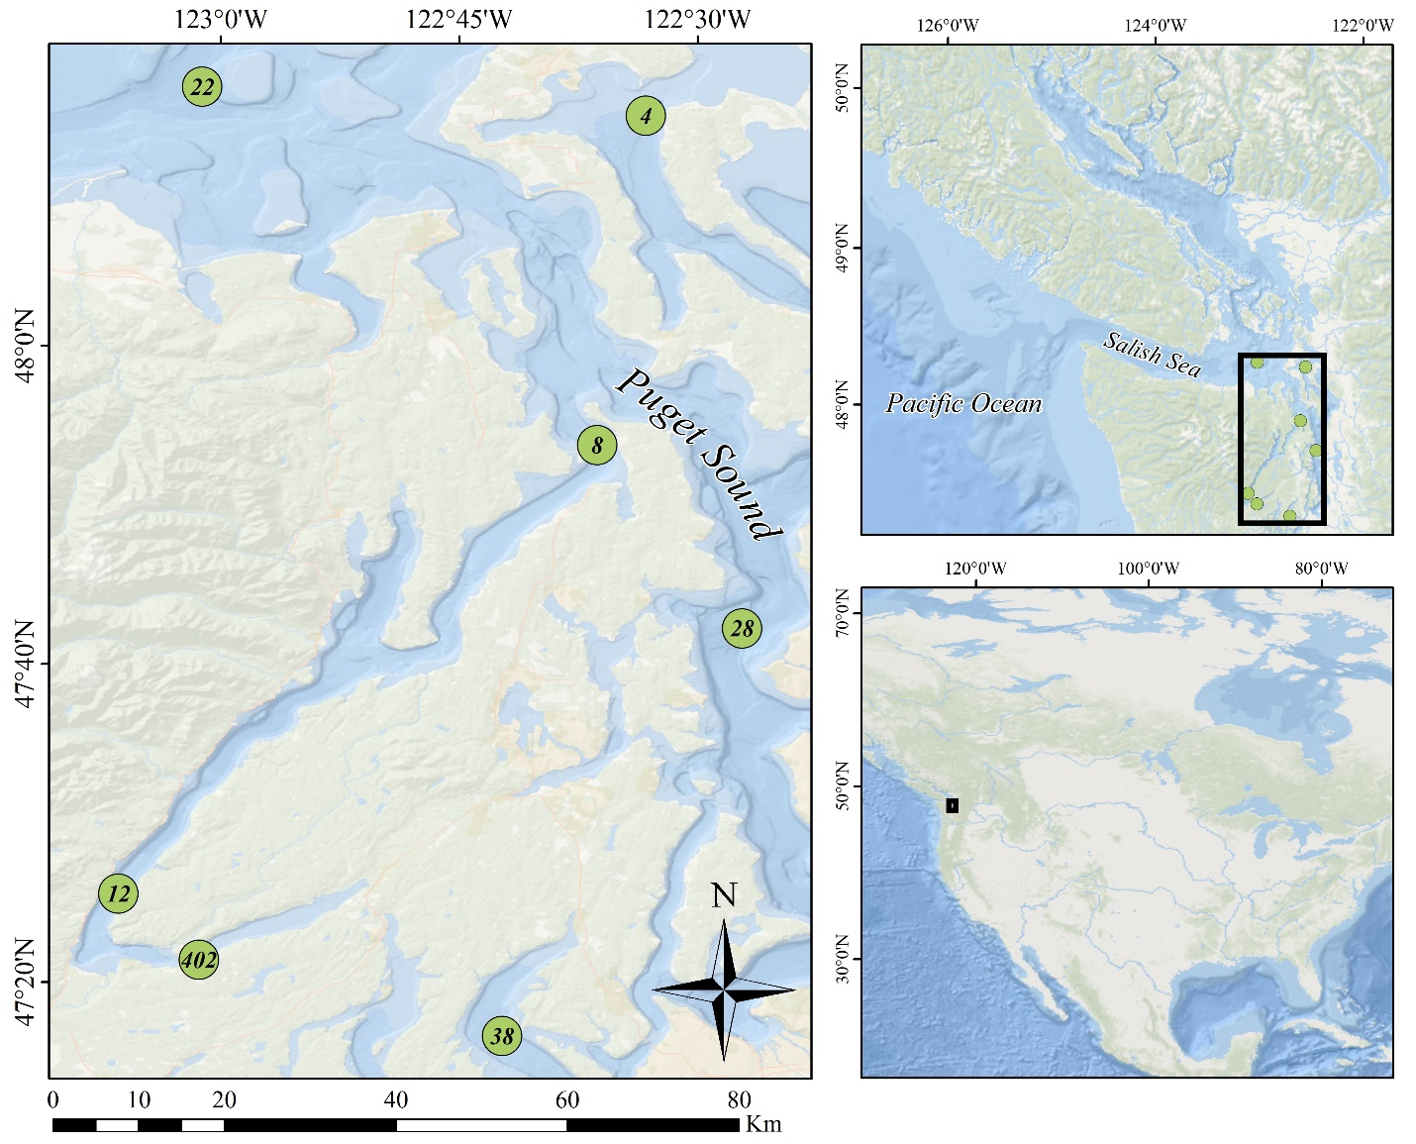

Figure 1: Locations of stations in the Salish Sea where pteropod and environmental sampling occurred. Samples were collected in April, July, and September from 2014 to 2016.

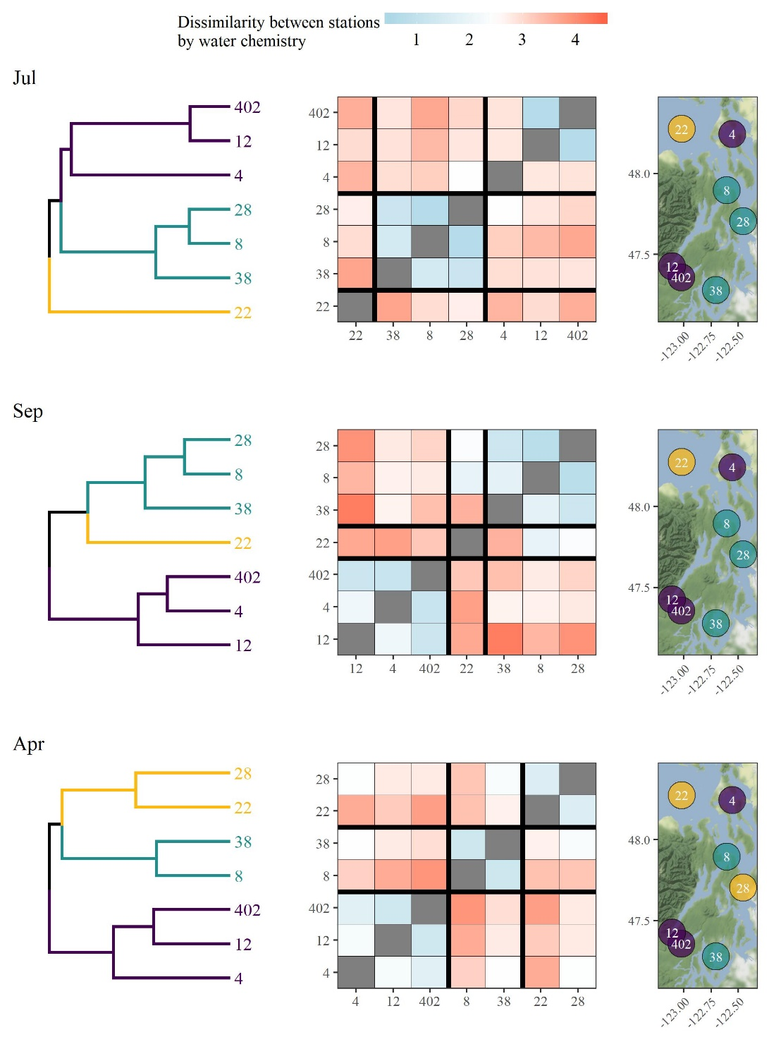

Figure 2: Clustering results of stations based on within-month averages for salinity, water temperature, dissolved oxygen, and aragonite saturation state. Within-month averages are based on all environmental data collected across the sample years from 2014 to 2016 in the same month. Results for each month (starting in July the prior year coinciding with spring spawning) are shown as dendrograms for site clustering (left), dissimilarity matrices showing mean Euclidean distances between observations at pairs of sites (middle), and spatial arrangements of the defined clusters (right). Cluster groups were set at three based on approximate dendrogram separation between sites to explain dominant patterns among environmental variables.

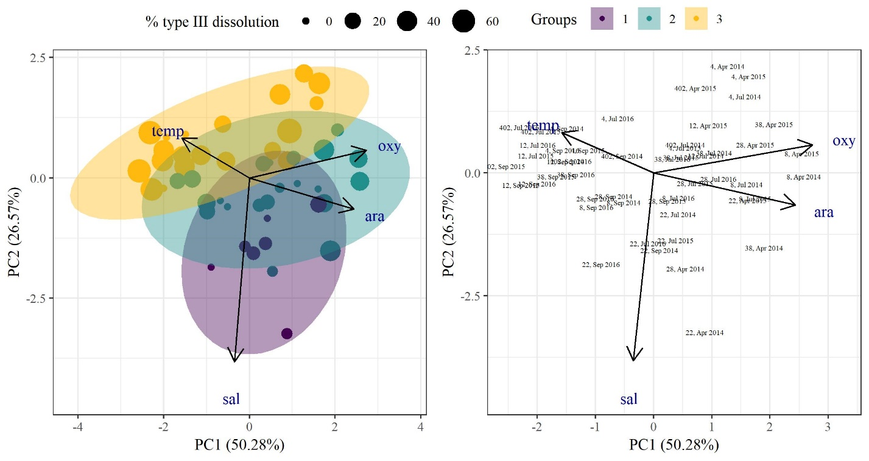

Figure 3: Results of principal components analysis for environmental variables collected at each site for each sample date. Environmental variables included temperature, salinity, dissolved oxygen, and aragonite saturation state. The left plot shows site groupings based on dominant clusters shown in Figure 2, with site points sized by measured type III dissolution for pteropods collected at the same location and date. The right plot shows the sites with text identifiers for the site number, followed by the month and sample year.

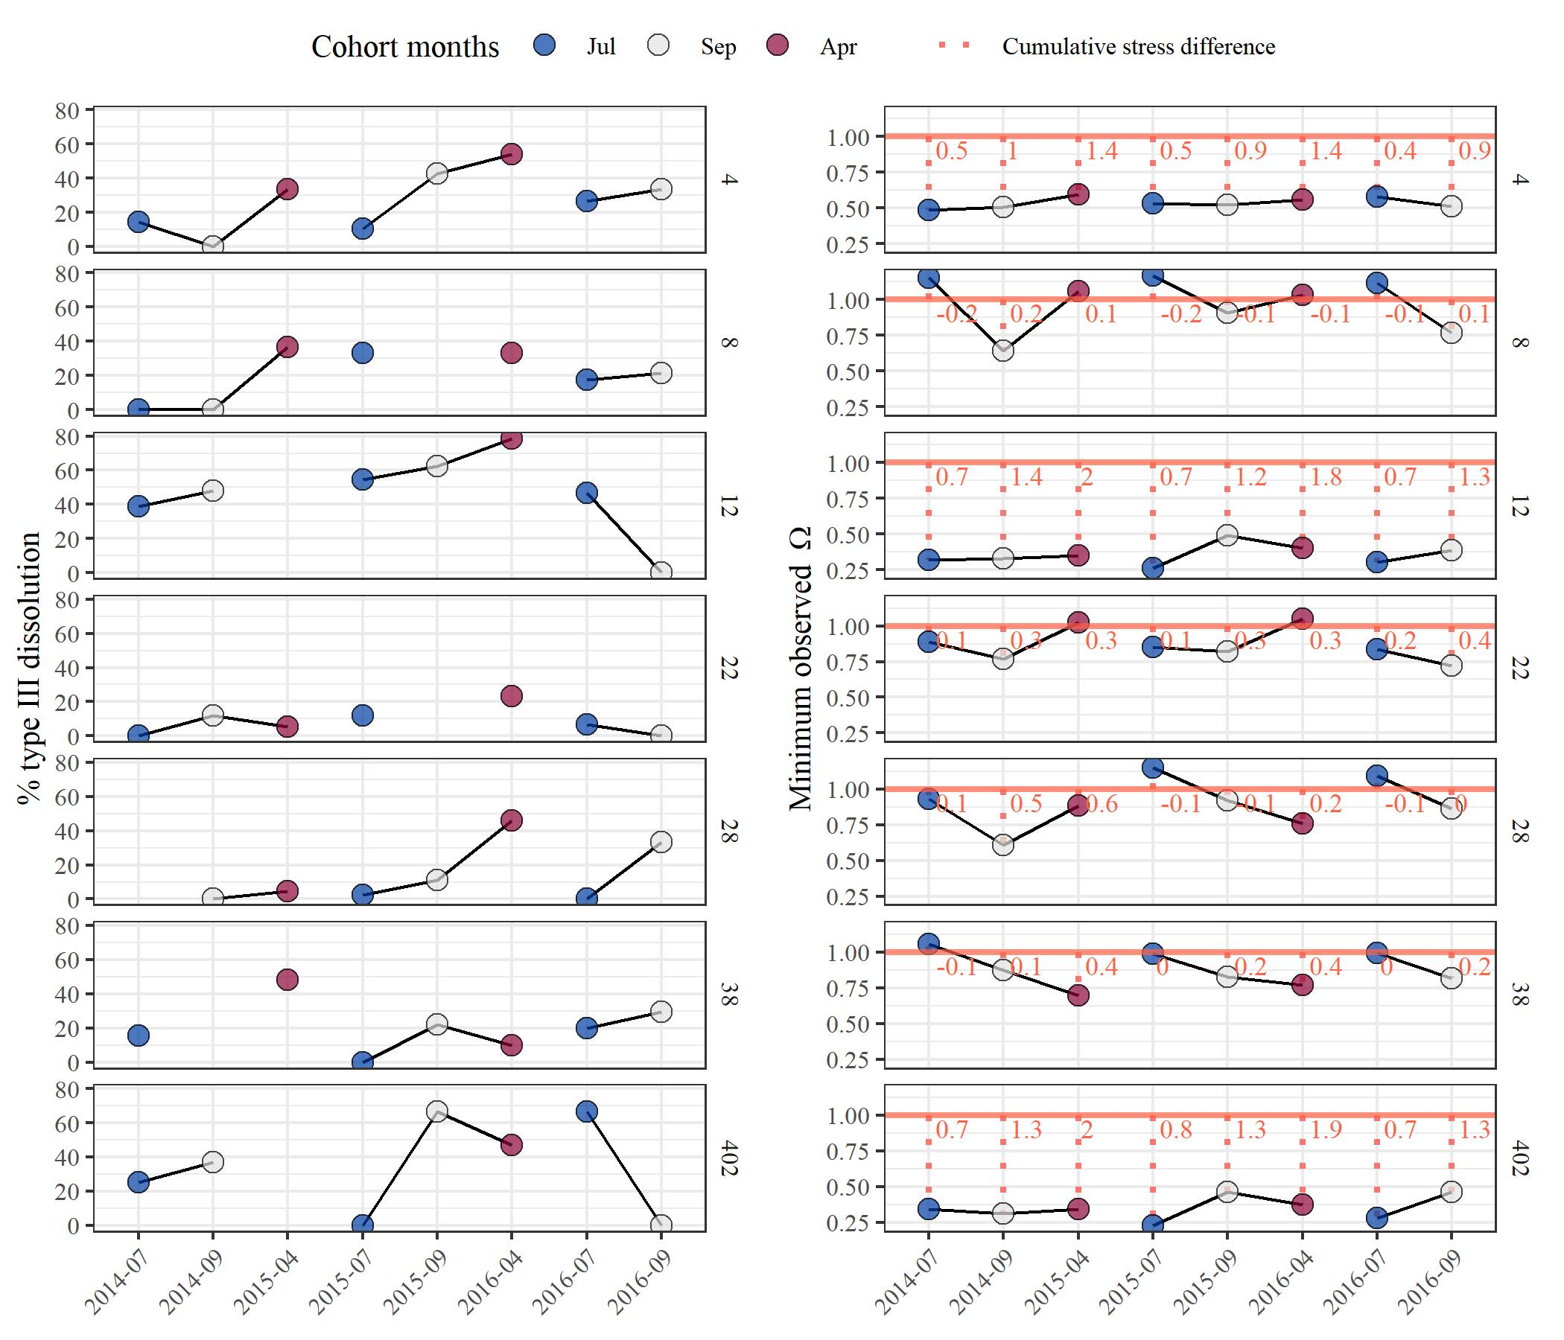

Figure 4: Observed time series for each station (rows) showing % type III dissolution of pteropods (left) and observed minimum aragonite saturation state (right). Points at each station are connected by cohort years. The right plot shows the selected aragonite threshold () as a horizontal line with the difference between the threshold and minimum observed value shown as a dotted line.

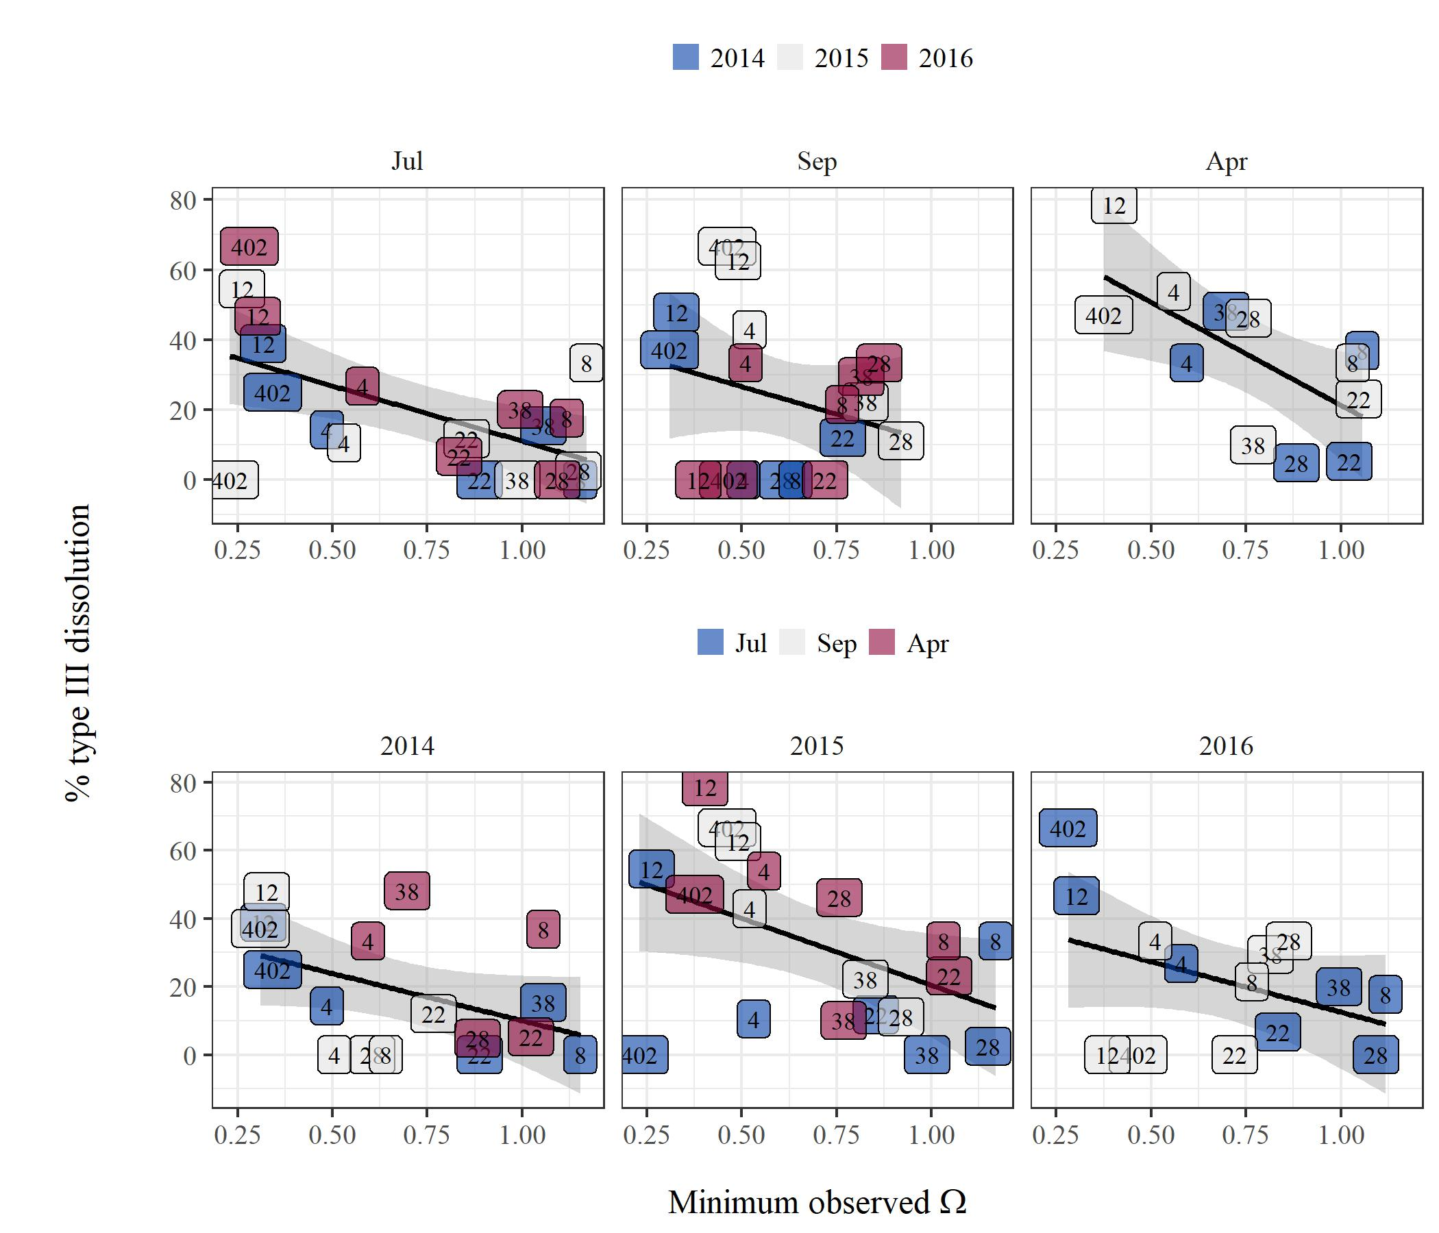

Figure 5: Percent type III dissolution measured in pteropods versus minimum observed aragonite saturation state for each station. The top row shows stations grouped by month across cohort years and the bottom row shows stations grouped by cohort years across months. Linear regression lines with 95% confidence intervals are shown in each panel.

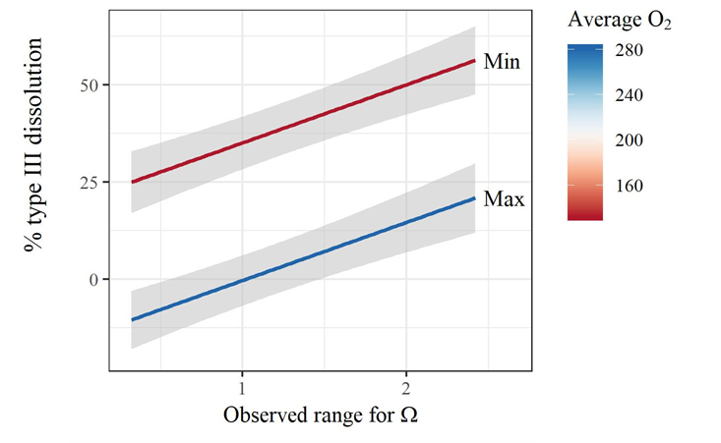

Figure 6: Interactions and additive effects of dissolved oxygen and aragonite saturation state on dissolution measures of pteropods. The top plot shows a linear model with a significant interaction between oxygen and the percentage of the water column undersaturated for aragonite, where the latter predictor had a significant main effect on dissolution. The bottom plot shows a linear model with significant main effects for both oxygen and the observed range of aragonite saturation state in the water column for each site. Each model is based on July observations across all sample years. The color range depicts the minimum and maximum observed values for average dissolved oxygen across all stations.

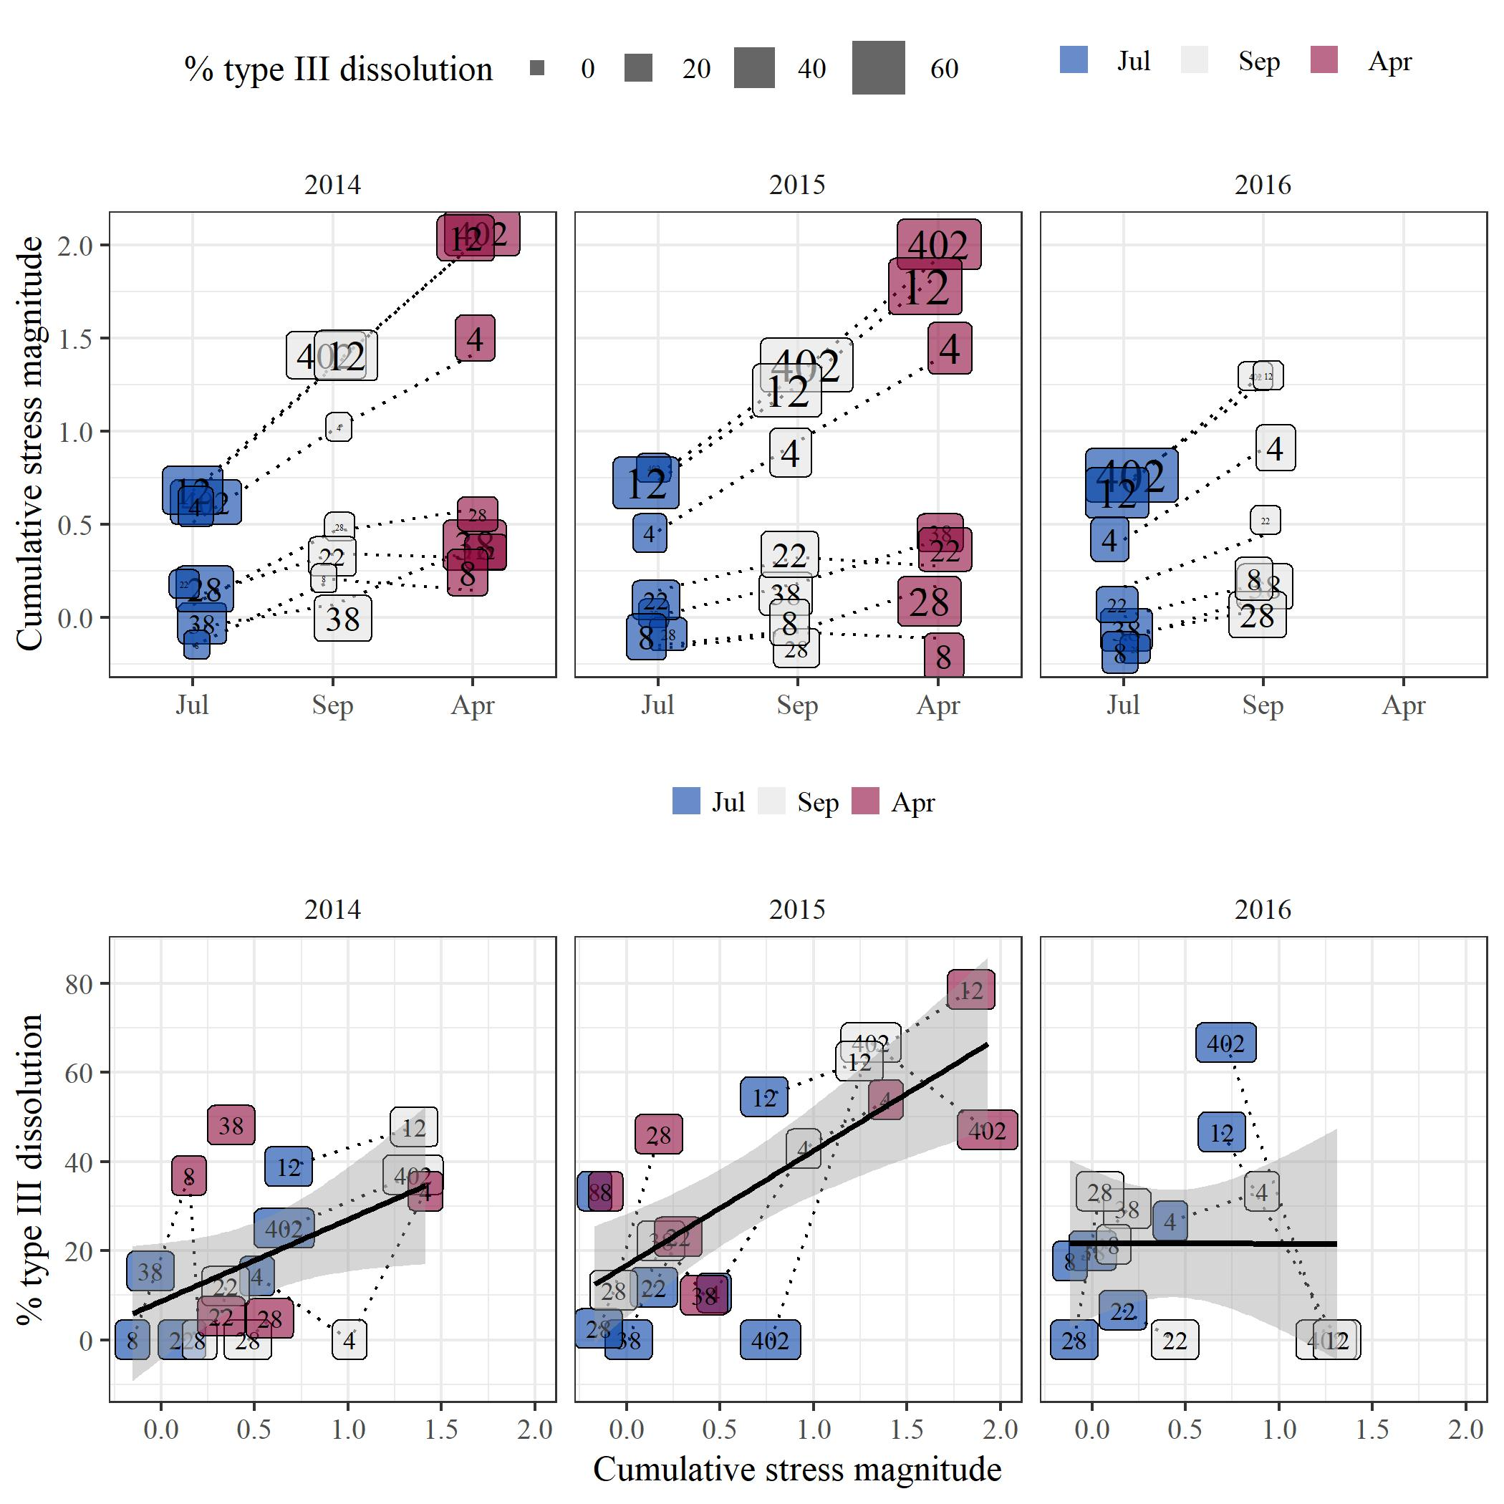

Figure 7: Relationships between percent type III dissolution and cumulative stress magnitude within cohort years. The top plot shows the progression of estimated cumulative stress from July to April throughout a cohort year for each station, with points sized by percent dissolution. The bottom plot shows the estimated linear relationship between percent dissolution and cumulative stress. The cumulative stress estimates within a year represent the frequency and magnitude of estimated exposure time of pteropods in a cohort when conditions were under-saturated below threshold .